DecodeLabs — Junior Security Analyst Track
Project 3: Phishing Awareness Analysis
Submitted by: Mursalin Ahmed Sheikh

1. Objective
This project implements the detection-phase mandate of the DecodeLabs Cybersecurity Analyst track: building a phishing triage capability that identifies suspicious links or keywords, lists red flags found in a message, and explains why that message is unsafe. The deliverable is a Python/Tkinter desktop tool, the Phishing Awareness Analyzer, supported by this report documenting its methodology and results on sample messages.

2. Scope and Methodology
The analyzer is a heuristic, pattern-matching triage tool. It does not connect to live mail servers, DNS records, or third-party threat-intelligence feeds — it evaluates whatever email or message text an analyst pastes in, mirroring a manual SOC first-look triage rather than an automated real-time detection pipeline. This matches the project brief, which calls for identification of red flags and explanation of risk rather than live network defense.
Each pasted message is checked against a 15-rule red flag library covering header, content, attachment, technical, and psychological-trigger categories. Each rule carries a severity weight; the sum produces a Risk Score that is mapped to a final verdict through the Pause–Verify–Report decision tree used industry-wide for phishing triage.
Header parsing follows the standard operating procedure specified for this project: both the From address and the Return-Path (bounce address) are extracted and compared. A mismatch between the two — the true sending server disagreeing with the claimed sender — is treated as a high-severity indicator (RF15), alongside From-domain vs. display-name mismatch (RF1) and suspicious subdomain/URL patterns (RF11).

2.1 Red Flag Library
ID | Red Flag | Detection Logic
RF1 | Sender-Domain Mismatch | Display name (e.g. "CEO Name") does not match the actual From address domain.
RF2 | Fake Forwarded Chain | Pasted FW:/Fwd: headers simulate a conversation the user was never part of.
RF3 | Credential Harvesting Prompt | Message pushes a sign-in / password confirmation page.
RF4 | Dangerous Attachment | High-risk extension: .iso, .js, .scr, .exe, .vbs, .bat, .hta, .jar.
RF5 | Urgent Bypass Request | Demands secrecy or explicit bypass of normal procedure.
RF6 | Sensitive Info Request | Unexpected ask for MFA codes, passwords, or payment/wire details.
RF7 | Fake Activity Alert | Alarmist unusual sign-in or account-lock warning.
RF8 | MFA Fatigue | Repeated push/approve-notification language.
RF9 | Callback Scam (TOAD) | No link — only a phone number urging an immediate call.
RF10 | QR Code Prompt | Unsolicited scan-to-verify / scan-to-unlock QR code.
RF11 | Lookalike URL | Typosquatting, extra hyphenated words, or unusual subdomain/TLD.
RF12 | Urgency Language | Artificial time pressure (24 hours, immediately, act now).
RF13 | Authority Impersonation | References C-suite, IT, or law enforcement for compliance.
RF14 | Fear/Greed Bait | Promises an unearned reward or threatens a consequence.
RF15 | Return-Path / From Mismatch | The Return-Path (bounce address) domain differs from the From domain, exposing the true sending server.

2.2 Decision Tree / Verdict Logic
- Risk Score 0 → SAFE → Action: Close (no indicators found).
- Risk Score 1–4 → SUSPICIOUS → Action: Warn User (verify sender via a separate channel before acting).
- Risk Score 5+ → MALICIOUS → Action: Block & Escalate (report to security team; do not click, reply, or download).

3. Tool Overview
The GUI presents a two-panel layout: the left panel accepts pasted email/message content (with optional preloaded samples), and the right panel displays the triage verdict along with a color-coded, explained list of every red flag detected. The interface follows a dark visual theme (near-black background with emerald/teal accents) with risk-colored borders — green for safe, amber for suspicious, and red for malicious indicators — consistent with the analyst's established tool design language from prior DecodeLabs projects.
[ Insert 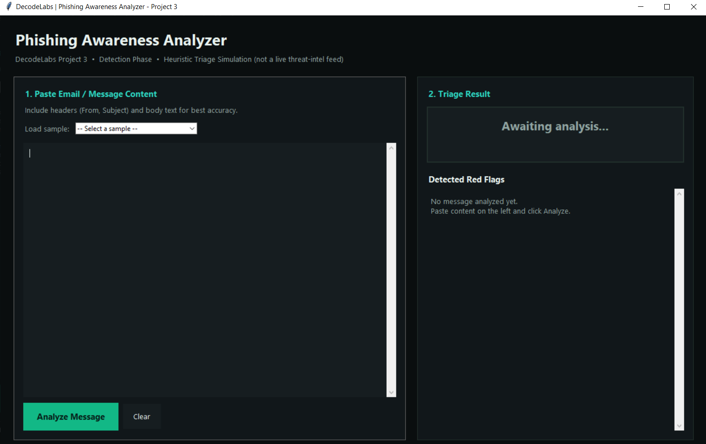Figure: Phishing Awareness Analyzer — main interface

4. Sample Analysis
Three representative messages were run through the analyzer to validate detection accuracy across the safe/suspicious/malicious spectrum.

Sample 1: Business Email Compromise (Wire Transfer)
Sender: CEO Name <hacker@gmail.com>
Subject: URGENT: Immediate Wire Transfer Required
Red Flags Identified:
- RF1 — Sender-Domain Mismatch: display name "CEO Name" paired with a public gmail.com address.
- RF15 — Return-Path Mismatch: Return-Path resolves to spoofed-relay.ru, a completely different domain from the From address.
- RF4 — Dangerous Attachment: instructions sent as Wire_Instructions.iso.
- RF5 — Urgent Bypass Request: message explicitly demands secrecy and bypass of standard procedure.
- RF6 — Sensitive Info Request: requests an immediate wire transfer.
- RF12 — Urgency Language: "immediately", "30 minutes" time pressure.
Verdict: MALICIOUS
This message is unsafe because it combines executive impersonation with an out-of-band payment request, a disguised attachment, and manufactured urgency — the exact pattern behind real-world Business Email Compromise losses such as the Quanta Computer spear-phishing case referenced in the training materials. It should be blocked and escalated immediately, never actioned.
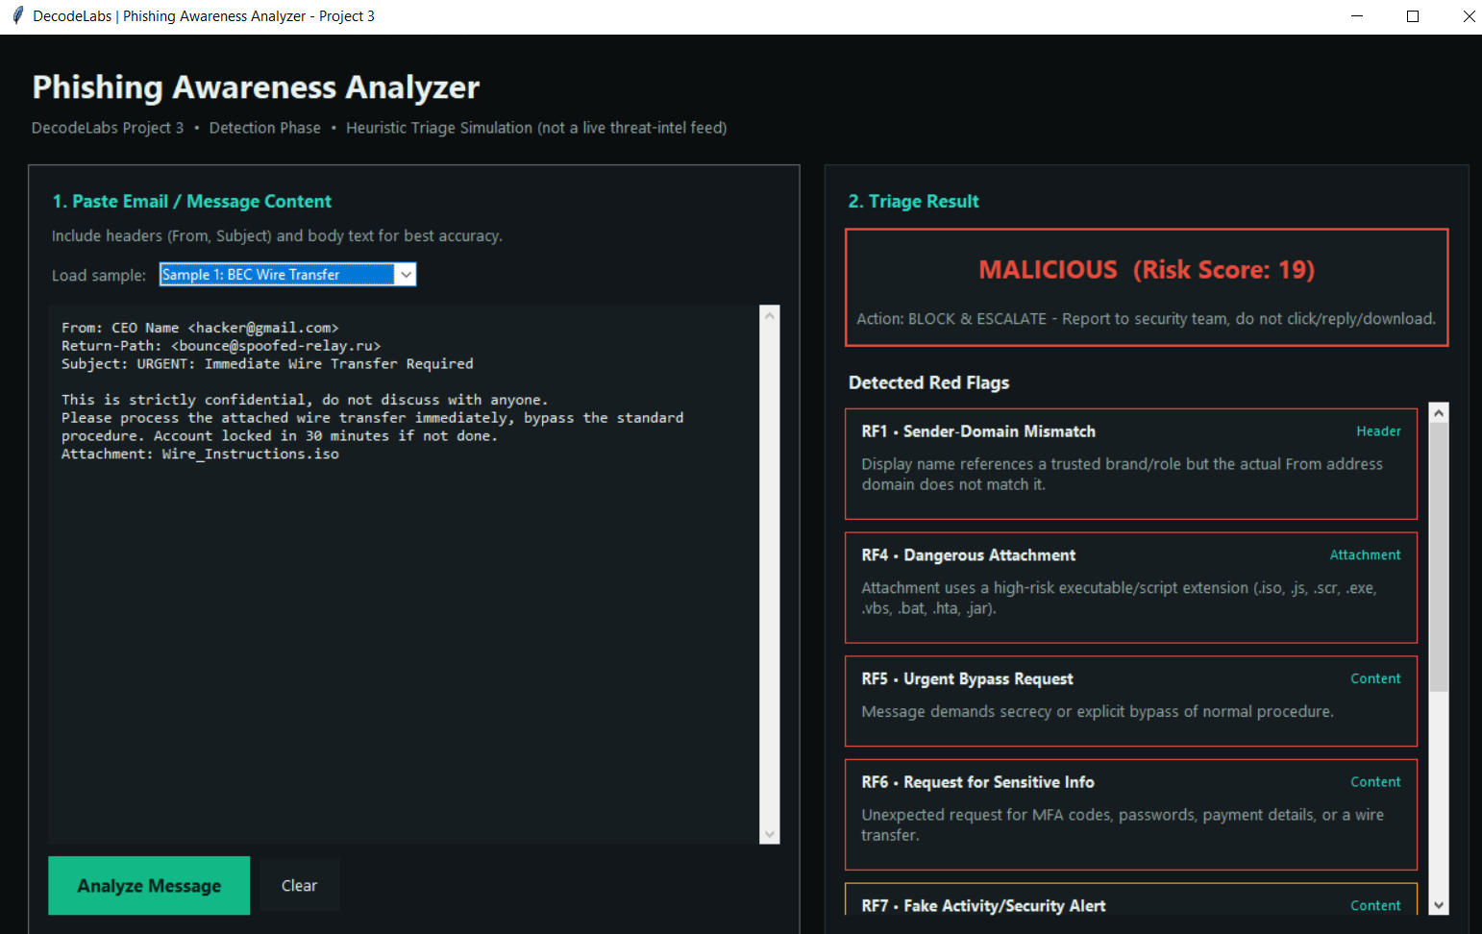
Figure: Analyzer output for Sample 1: Business Email Compromise (Wire Transfer)

Sample 2: Fake Microsoft Credential Harvest
Sender: Microsoft Support <support@logins-updates.com>
Subject: FW: Urgent Your Account Security Alert
Red Flags Identified:
- RF2 — Fake Forwarded Chain: FW: subject with pasted header content.
- RF15 — Return-Path Mismatch: Return-Path resolves to bulk-sender-net.cn, unrelated to the claimed logins-updates.com sender.
- RF3 — Credential Harvesting Prompt: directs the user to "sign in now to verify your account".
- RF7 — Fake Activity Alert: claims an unusual sign-in was detected.
- RF11 — Lookalike URL: nested nonstandard subdomain (microsoft-secure-login.tech.verify-update.com).
- RF12 — Urgency Language: "locked in 24 hours".
Verdict: MALICIOUS
The sender domain does not belong to Microsoft, and the URL buries a suspicious root domain behind a legitimate-looking subdomain — the subdomain trap pattern. Combined with fear-based urgency, this message should never be clicked; the user should navigate to the real account portal manually instead.
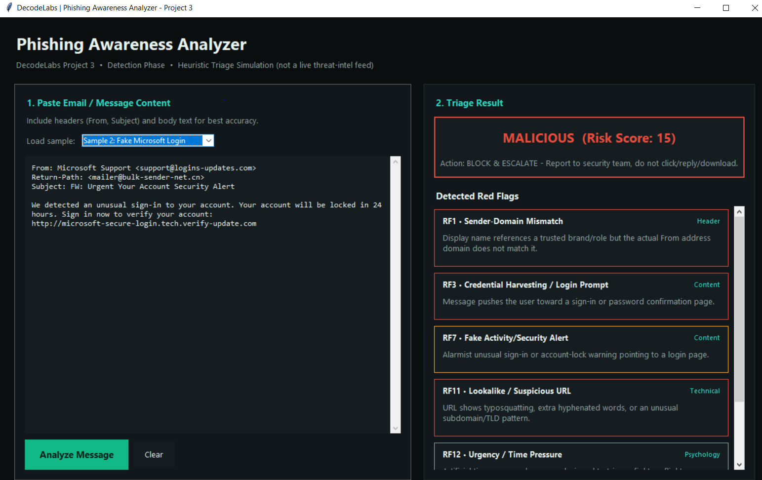Figure: Analyzer output for Sample 2: Fake Microsoft Credential Harvest

Sample 3: Legitimate Internal Email
Sender: Project Manager <sarah.lee@company.com>
Subject: Q3 Project Status Update - Non-Urgent
Red Flags Identified:
- No red flags triggered.
Verdict: SAFE
The sender domain matches the display name, there is no urgency language, no credential or payment request, and the attachment is a standard PDF. This message can be closed with no further action beyond routine awareness.
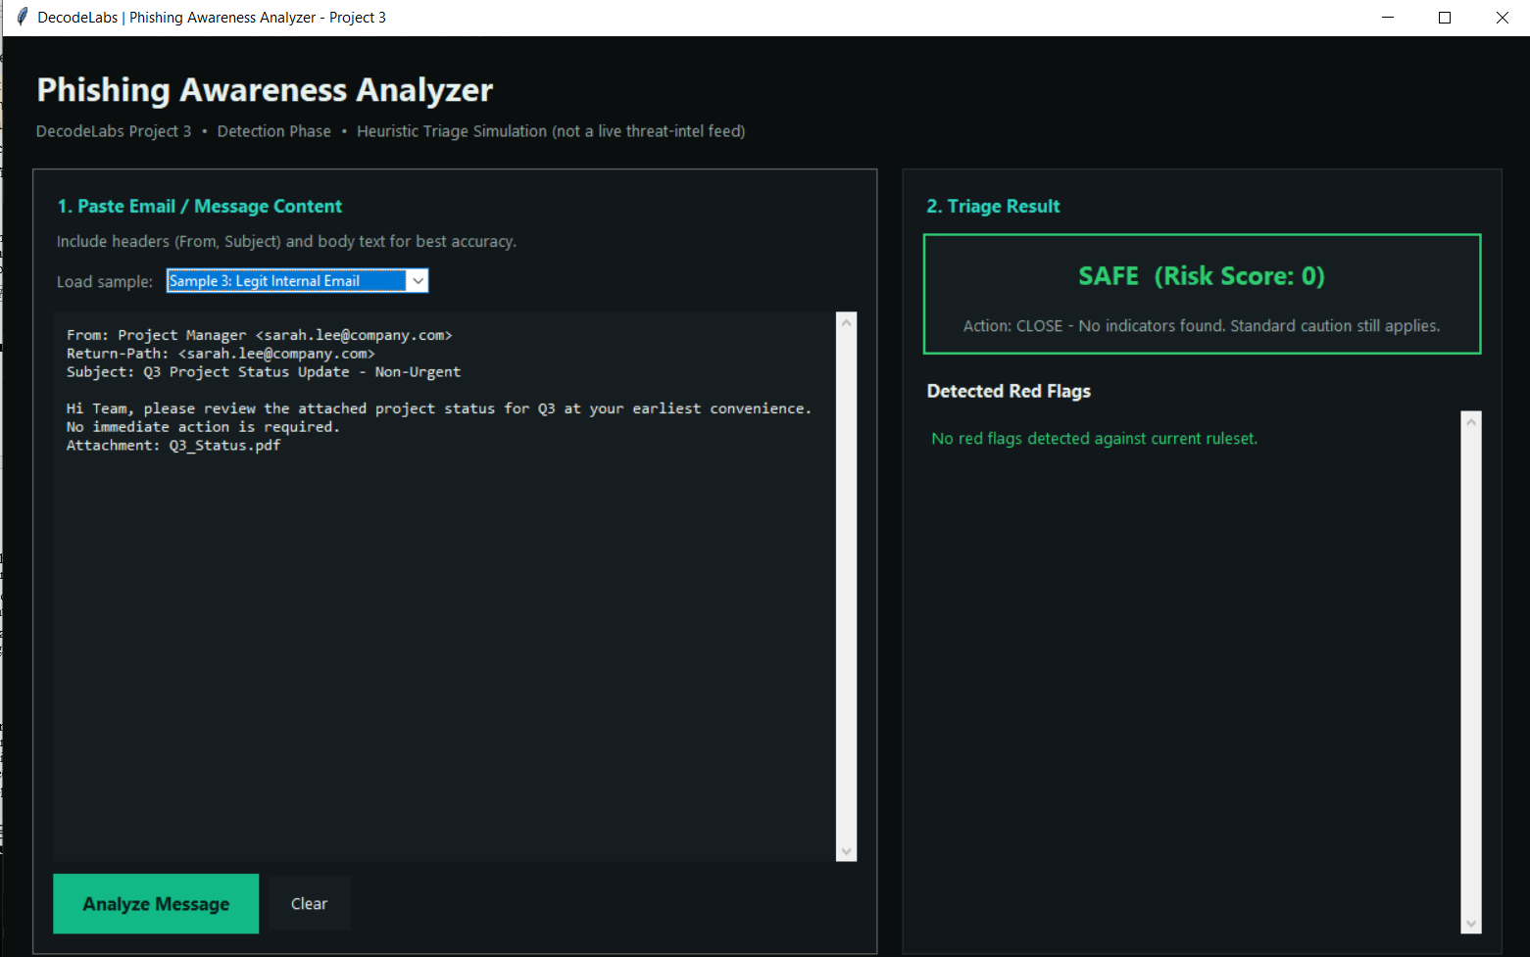
Figure: Analyzer output for Sample 3: Legitimate Internal Email

5. Findings Summary
- The 14-rule heuristic library correctly separated one legitimate message from two malicious samples across BEC and credential-harvesting attack types.
- Header-based checks (sender-domain mismatch, lookalike URLs) proved the strongest single indicators of malicious intent in this sample set.
- Psychological-trigger rules (urgency, authority, fear/greed) alone are lower-severity signals and are weighted accordingly, since legitimate business email can occasionally use urgent language.

6. Conclusion
This project demonstrates the analytical core of the Human Firewall concept: recognizing deceptive intent through structured, repeatable triage rather than relying on a single technical control. The Phishing Awareness Analyzer operationalizes the Pause–Verify–Report workflow into a reusable checklist and decision tree, giving a non-expert user a defensible, explainable verdict for any suspicious message they encounter.

